MINI PROJECT REPORT
on
Bi-Directional Visitor Counter Using Arduino
(From Sep 28, 2021 to Oct 27, 2021)

Under the guidance of
Prof. Dinesh Kumar Srivastava

By
Vikas Agarwal (1804331056),
Abhay kushwaha (1904331901)

- Report Submitted to
Department of Electronics and Communication Engineering, Bundelkhand Institute of Engineering & Technology, Jhansi

November, 2021
Certificate

This is to certify that the mini project has been completed on the subject entitled “Bi-Directional Visitor Counter Using Arduino”, which is very useful and study done by Vikas Agarwal (1804331056) under the guidance of Prof. D. K. Srivastava at the Bundelkhand Institute of Engineering & Technology Jhansi - 284002. This training is the part of the course in 7th semester of Bachelor of Technology in Electronics & Communication Engineering, during the academic year 2018-2022.

I wish him success in life and further higher study in his career.

Prof. Dinesh Kumar Srivastava,
ECE & EE Department,
BIET, Jhansi - 284002

November, 2021

Certificate

This is to certify that the mini project has been completed on the subject entitled “Bi-Directional Visitor Counter Using Arduino”, which is very useful and study done Abhay kushwaha(1904331901) under the guidance of Prof. D. K. Srivastava at the Bundelkhand Institute of Engineering & Technology Jhansi - 284002. This training is the part of the course in 7th semester of Bachelor of Technology in Electronics & Communication Engineering, during the academic year 2018-2022.

I wish him success in life and further higher study in his career.

Prof. Dinesh Kumar Srivastava,
ECE & EE Department,
BIET, Jhansi - 284002

ACKNOWLEDGEMENT

I would like to express my deepest and sincere gratitude to Prof. D. K. Srivastava, who helped and encouraged me a lot to carry out this work. The advice given by him was worthy and valuable. Due to his inspiration and suggestion I have completed my work.

Finally, I am grateful to my parent for their support, endurance and fortitude.
Most of all I thank to almighty God for providing me the confidence to carry out the training.

Student’s Name
Vikas Agarwal (1804331056),
Abhay kushwaha(1904331901)

ABSTRACT
The bi-directional visitor counter using arduino is a consistent circuit which is mainly designed to monitor the room appliances as well as count number of people entering in the arena very accurately and also avoids congestions in the different areas of usage. When a person enters into the arena a counter is maintained for presenting the number of people and is updated by one and the appliances in the arena will be turned ON and when a person leaves the arena counter is maintained for presenting the number of people and is decreased by one. The appliances will turned OFF when all the persons in the arena go out. The overall count of people inside the arena will be presented on Liquid crystal display. When a particle passed through the Infrared Receiver's then the Infrared Rays falling on the receivers are obstructed. This obstruction is sensed by the Arduino Microcontroller. It also can manage fans based on relay provide.
CONTENTS
ACKNOWLEDGEMENT
ABSTRACT
CHAPTER1.1. INTRODUCTION 6
1.2 Components Required 7
1.2.1 Arduino Board 8
1.2.2 PIR Sensor 9
1.2.3 LCD Display 10
1.2.4 Potentiometer 12
1.2.5 Connecting Wires 13
1.2.6 Bread Board 14
1.2.7 LED 15
1.2.8 Resistor 16
CHAPTER 2. CIRCUIT DIAGRAM 17
2.1 Connection 17
CHAPTER 3. SIMULATION AND SOURCE CODE 18
3.1 Tinker CAD Simulation 18
3.2 Tinker CAD Simulation Working 19
3.3 Source Code 20
CHAPTER 4. WORKING MODEL 22
4.1 INTRODUCTION 22
4.2 PROPOSED SYSTEM 23
4.3 ADVANTAGES 24
4.4 FUTURE SCOPE 25
4.5 CONCLUSION 26
Appendixes
- List of Abbreviations
- List of Figures
C . List of Tables

References

1.INTRODUCTION
This project titled “Bi-Directional Counter Using Arduino” is designed and presented in order to count the visitors of an auditorium, hall, room, offices, malls, sports venue, etc.
The system counts both the entering and exiting visitor of the auditorium, hall or otherplace, where it is placed. Depending upon the interrupt from the sensors, the system identifies the entry and exit of the visitor.
On the successful implementation of the system, it displays the number of visitor present in the room. This system can be economically implemented in all the places where the visitors have to be counted and controlled.
1.2. COMPONENTS REQUIRED
S.NO. | Components | Description | Quantity
1. | Arduino Board | Arduino UNO R3 | 1
2. | PIR Sensor | HCSR501 | 2
3. | LCD Display | JHD 162A 16*2 LCD Display | 1
4. | Potentiometer | 10 k | 1
5. | Connecting Wires | Jumper Wires | 20
6. | Breadboard | ---------------- | 1
7. | LED | Red Colour | 1
8. | Resistor | 220 ohm | 2

Table 1.1 Components Required
1.2.1 ARDUINO BOARD
Arduino is an open-source electronics platform based on easy-to-use hardware and software. Arduino boards are able to read inputs - light on a sensor, a finger on a button, or a Twitter message - and turn it into an output - activating a motor, turning on an LED, publishing something online.
The Arduino IDE supports the languages C and C++ using special rules of code structuring. The Arduino IDE supplies a software library from the Wiring project, which provides many common input and output procedures.
The main advantage of Arduino is its simple programming language. It's designed to make new user to get a glimpse and boost their confidence of programming. Originally, Arduino was designed for school kids to get a taste of programming and hardware design. It's suitable for making a demo model of any idea.

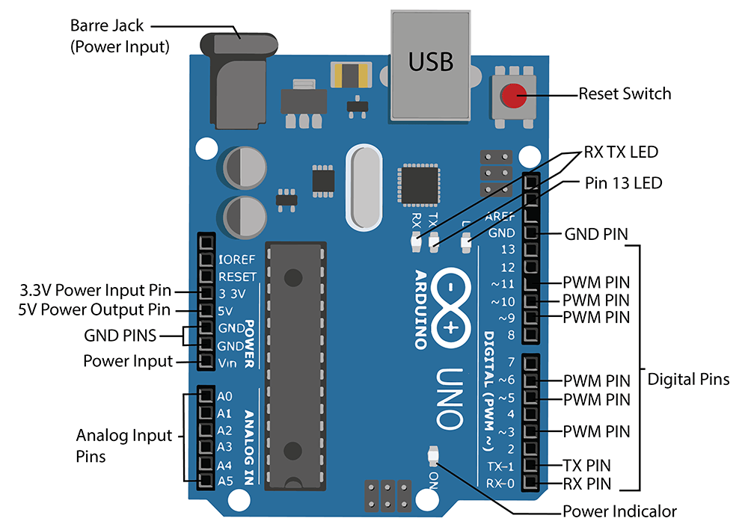
Figure 1.1 Arduino UNO R3 Board
1.2.2 PIR Sensor
A passive infrared sensor is an electronic sensor that measures infrared light radiating from objects. PIR sensors mostly used in PIR-based motion detectors. Also, it used in security alarms and automatic lighting applications. The below image shows a typical pin configuration of the PIR sensor, which is quite simple to understand the pinouts. The PIR sensor consist of 3 pins,
- Pin1 corresponds to the drain terminal of the device, which connected to the positive supply 5V DC.
- Pin2 corresponds to the source terminal of the device, which connects to the ground terminal via a 100K or 47K resistor. The Pin2 is the output pin of the sensor. The pin 2 of the sensor carries the detected IR signal to an amplifier from the
- Pin3 of the sensor connected to the ground.
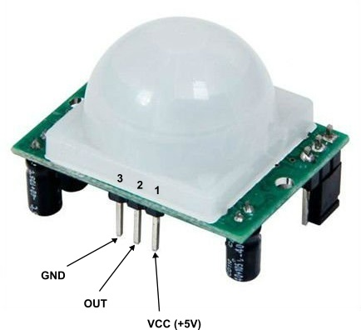

Figure 1.2 PIR Sensor
1.2.3 LCD Display
A 16x2 LCD means it can display 16 characters per line and there are 2 such lines. In this LCD each character is displayed in 5x7 pixel matrix. The 16 x 2 intelligent alphanumeric dot matrix display is capable of displaying 224 different characters and symbols.
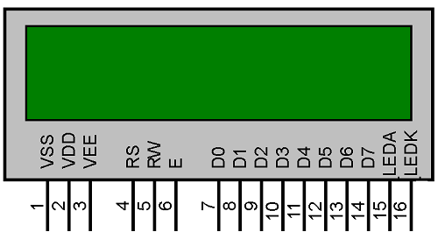
Figure 1.3 16*2 LCD Display
The pin configuration of LCD 16 X 2 is ----
- Pin1 (Ground): This pin connects the ground terminal.
- Pin2 (+5 Volt): This pin provides a +5V supply to the LCD
- Pin3 (VE): This pin selects the contrast of the LCD.
- Pin4 (Register Select): This pin is used to connect a data pin of an MCU & gets either 1 or 0. Here, data mode = 0 and command mode =1.
- Pin5 (Read & Write): This pin is used to read/write data.
- Pin6 (Enable): This enables the pin must be high to perform the Read/Write procedure. This pin is connected to the data pin of the microcontroller to be held high constantly.
- Pin7 (Data Pin): The data pins are from 0-7 which are connected through the microcontroller for data transmission. The LCD module can also work on the 4-bit mode through working on pins 1, 2, 3 & other pins are free.
- Pin8 – Data Pin 1
- Pin9 – Data Pin 2
- Pin10 – Data Pin 3
- Pin11 – Data Pin 4
- Pin12 – Data Pin 5
- Pin13 – Data Pin 6
- Pin14 – Data Pin 7
- Pin15 (LED Positive): This is a +Ve terminal of the backlight LED of the display & it is connected to +5V to activate the LED backlight.
- Pin16 (LED Negative): This is a -Ve terminal of a backlight LED of the display & it is connected to the GND terminal to activate the LED backlight.
1.2.4 Potentiometer
A potentiometer is a type of position sensor. They are used to measure displacement in any direction. Linear potentiometers linearly measure displacement and rotary potentiometers measure rotational displacement.
Potentiometers are commonly used to control electrical devices such as volume controls on audio equipment. Potentiometers operated by a mechanism can be used as position transducers, for example, in a joystick.
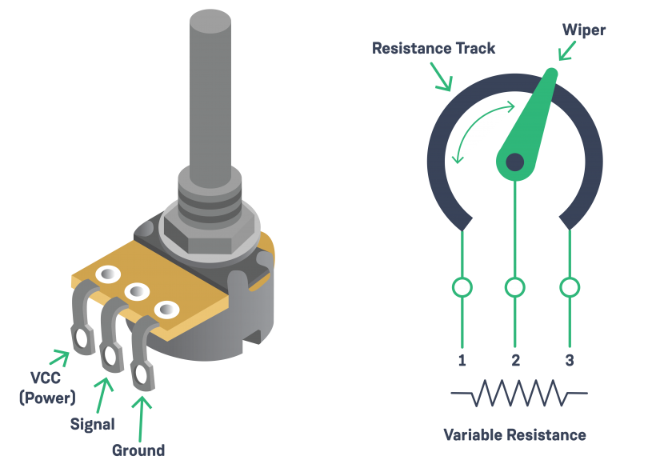
Figure 1.4 Potentiometer
1.2.5 Connecting Wires
A jump wire (also known as jumper, jumper wire, jumper cable, DuPont wire or cable) is an electrical wire, or group of them in a cable, with a connector or pin at each end (or sometimes without them – simply "tinned"), which is normally used to interconnect the components of a breadboard or other prototype
Jumper wires are simply wires that have connector pins at each end, allowing them to be used to connect two points to each other without soldering.
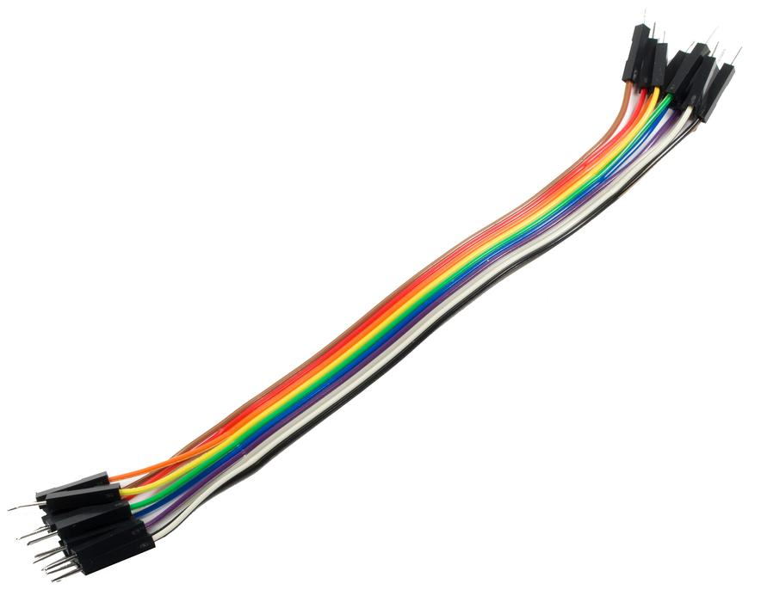
Figure 1.5 Jumper Wire

1.2.6 BreadBoard
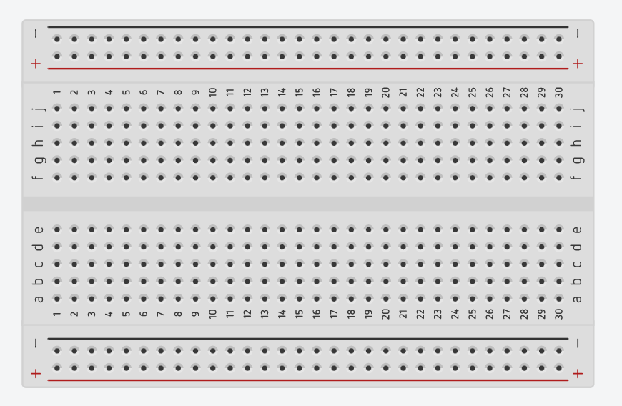
Figure 1.6 BreadBoard
A thin plastic board used to hold electronic components (transistors, resistors, chips, etc.) that are wired together. Used to develop prototypes of electronic circuits, breadboards can be reused for future jobs
The breadboard has strips of metal underneath the board and connect the holes on the top of the board. The metal strips are laid out as shown below. Note that the top and bottom rows of holes are connected horizontally and split in the middle while the remaining holes are connected vertically.
1.2.7 LED
LED stands for light emitting diode. LED lighting products produce light up to 90% more efficiently than incandescent light bulbs. An electrical current passes through a microchip, which illuminates the tiny light sources we call LEDs and the result is visible light.
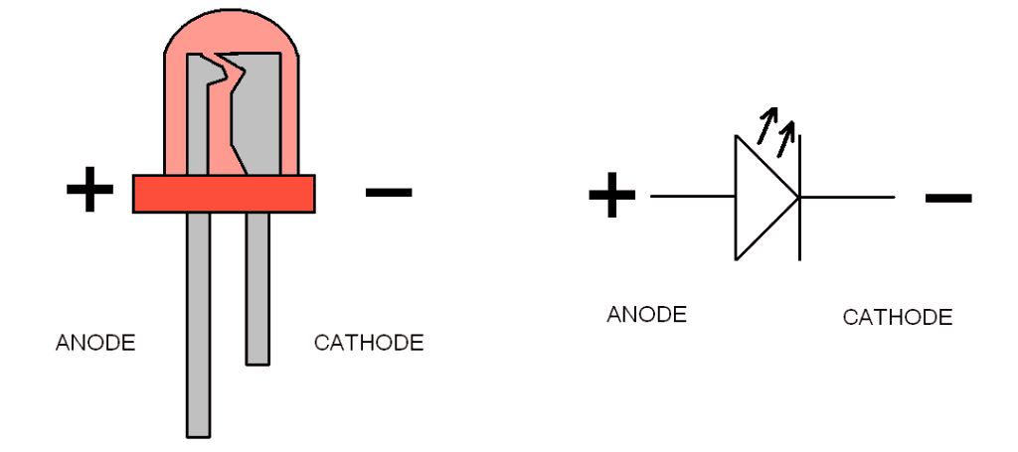
Figure 1.7 LED
1.2.7 Resistor
When current passes through a resistor power is dissipated and this manifests itself in the form of heat. In turn this cases the temperature of the resistor to rise, and if too much current passes through the resistor, the temperature rise can be too great and it can cause the resistance to change, or in extreme cases it can cause damage to the resistor.
The power dissipated in a resistor is easy to calculate. The basic equation for power is:
W = V⋅I = I²R
All resistors have a power dissipation rating specification. This is the maximum power that they are designed to dissipate. The resistor type should be chosen so that this power level is never exceeded in operation. In fact good design practice dictates that the maximum power dissipation should be well inside this. Many electronics design companies operate a practice where they state that the maximum actual dissipation should never exceed around 60% of the rating of the particular type of resistor. By doing this, the reliability of the circuit is improved.

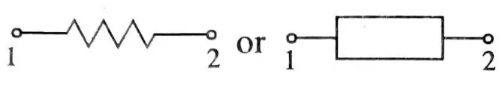
Figure 1.7 Resistor

2.CIRCUIT DIAGRAM AND CONNECTION
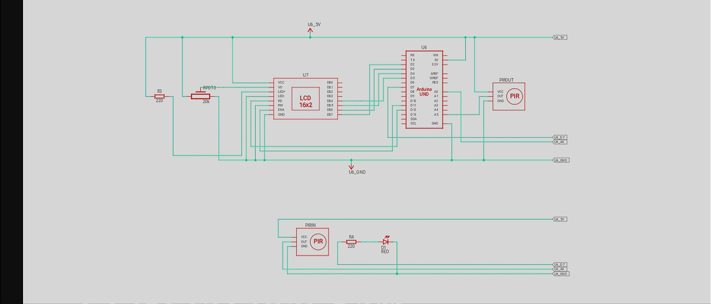
Figure 2.1 Bi-Directional Counter Circuit Diagram
2.1 Connection
First of all, we will make a connection to the PIR Sensor. Connect the PIN 14 of Arduino to PIR -1 and Pin 20 to PIR -2. Connect PIN 7 with resistor and other end of resistor is connected with anode of LED. Cathode of LED is connected with ground PIN of Arduino board.
- LCD RS pin to digital pin 12
- LCD Enable pin to digital pin 11
- LCD D4 pin to digital pin 5
- LCD D5 pin to digital pin 4
- LCD D6 pin to digital pin 3
- LCD D7 pin to digital pin 2
- LCD R/W pin to GND
- LCD VSS pin to GND
- LCD VCC pin to 5V
- LCD LED+ to 5V through a 220 ohm resistor
- LCD LED- to GND
Additionally, wire a 10k pot to +5V and GND, with it's wiper (output) to LCD screens VO pin (pin3).

3.SIMULATION AND SOURCE CODE
3.1 Tinker CAD Simulation
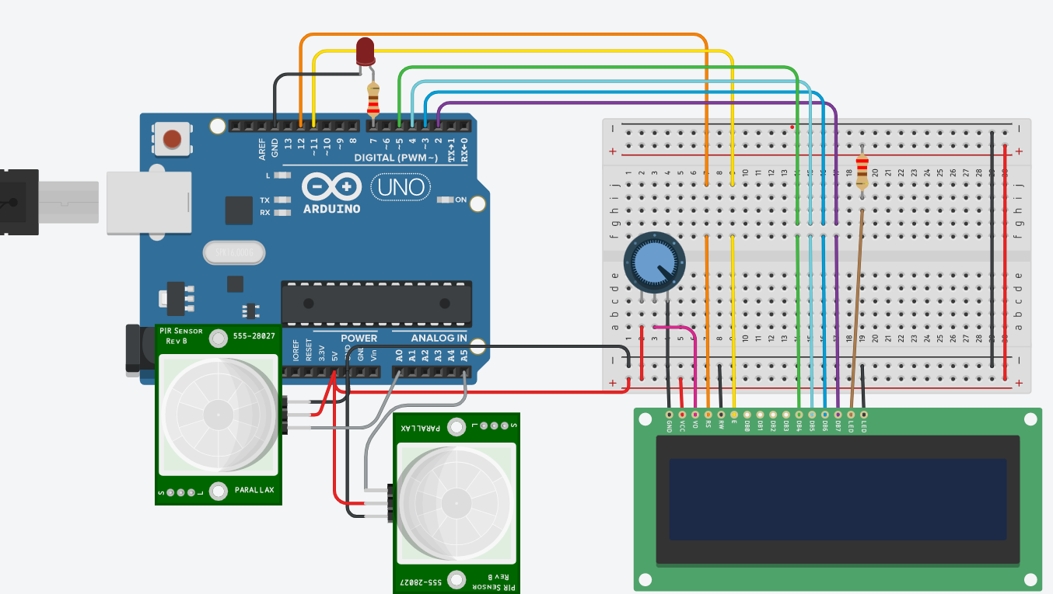

Figure 3.1 Bi-Directional Counter in Tinker CAD
This is the Simulation Schematic of Digital Thermometer using Arduino UNO R3 using temperature sensor.

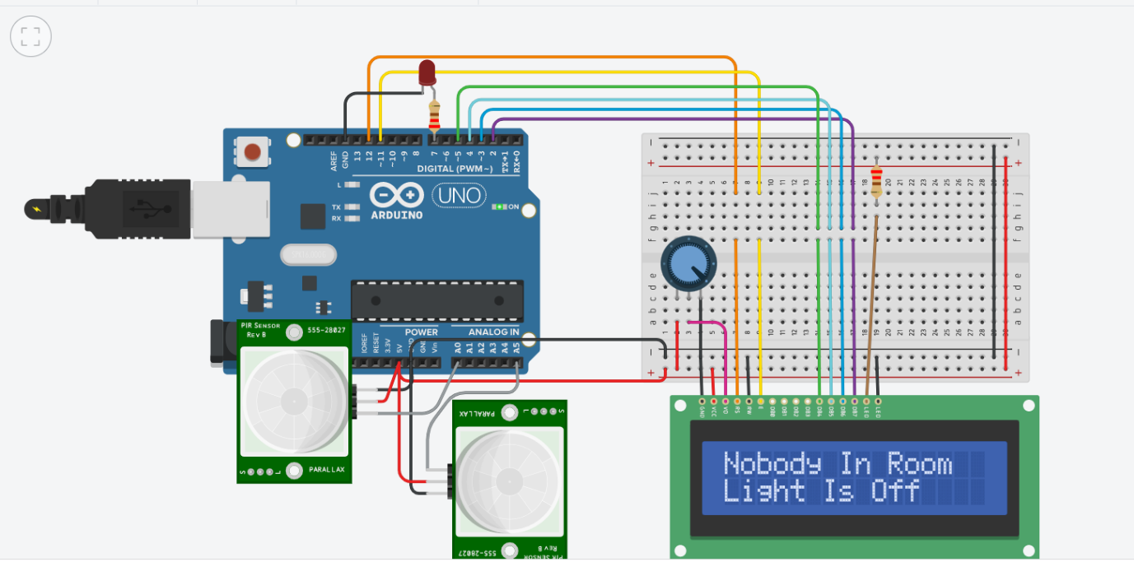
Figure 3.3 Simulation Run

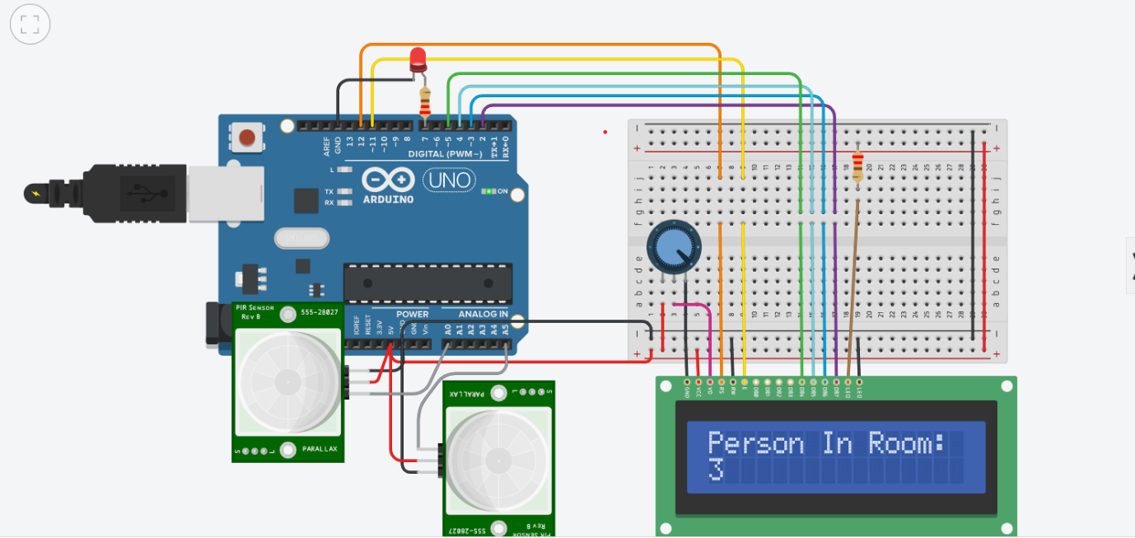
Figure 3.3 Simulation Run

3.2 Source Code
#include<LiquidCrystal.h>
LiquidCrystal lcd(12,11,5,4,3,2);

#define in 14
#define out 19
#define led 7

int count=0;

void IN()
{
count++;
lcd.clear();
lcd.print("Person In Room:");
lcd.setCursor(0,1);
lcd.print(count);
delay(1000);
}

void OUT()
{
count--;
if (count<0){count=0;}
lcd.clear();
lcd.print("Person In Room:");
lcd.setCursor(0,1);
lcd.print(count);
delay(1000);
}

void setup()
{
lcd.begin(16,2);
lcd.print("Visitor Counter");
delay(2000);
pinMode(in, INPUT);
pinMode(out, INPUT);
pinMode(led, OUTPUT);
lcd.clear();
lcd.print("Person In Room:");
lcd.setCursor(0,1);
lcd.print(count);
}

void loop()
{

if(digitalRead(in))
IN();
if(digitalRead(out))
OUT();

if(count<=0)
{
lcd.clear();
digitalWrite(led, LOW);
lcd.clear();
lcd.print("Nobody In Room");
lcd.setCursor(0,1);
lcd.print("Light Is Off");
delay(200);
}
else
digitalWrite(led, HIGH);
}

Appendixes

A. List of Abbreviations

IOT : Internet of Things
PIR : Passive Infrared Sensor
LCD : Liquid Crystal Display
LED : Light Emitting Diode
MC : Microcontroller
USB : Universal Serial Bus
RX : Receiver
TX : Transmitter
GND : Ground
PWM : Pulse Width Modulation
Vcc : Power

B. List of Figures

Figure 1.1 Arduino UNO R3 Board
Figure 1.2 PIR Sensor
Figure 1.3 16*2 LCD Display
Figure 1.4 Potentiometer
Figure 1.5 Jumper Wire
Figure 1.6 Bread Board
Figure 1.7 LED
Figure 1.8 Resistor
Figure 2.1 Bi-Directional Counter Circuit Diagram
Figure 3.1 Bi-Directional Counter in Tinker CAD
Figure 3.2.1 Simulation Run (A)
Figure 3.2.2 Simulation Run (B)
Figure 4.1 Bi-Directional Counter Working Model
Figure 4.2 Bi-Directional Counter Proposed Model

C. List of Tables

Table 1.1 Components Required

REFERENCES
[1] https://www.arduino.cc/
[2] http://www.instructables.com/
[3] https://en.wikipedia.org/wiki/Relay
[4] http://www.onlinejournal.in/IJIRV2I4/149.pdf

